1.What are the different 802.11 PHY layer standards? Compare their characteristics.
Standard | Frequency Band | Max Data Rate | Range | Technology Used | Key Features
802.11a | 5 GHz | 54 Mbps | Short | OFDM | Less interference, lower range
802.11b | 2.4 GHz | 11 Mbps | Long | DSSS | Better range, slower speed
802.11g | 2.4 GHz | 54 Mbps | Medium | OFDM | Backward compatible with b
802.11n | 2.4/5 GHz | 600 Mbps | Long | MIMO, OFDM | Higher speed, better coverage
802.11ac | 5 GHz | 1.3 Gbps+ | Medium | MU-MIMO, OFDM | Very high speed, better performance
802.11ax (Wi-Fi 6) | 2.4/5 GHz | 9.6 Gbps | Long | OFDMA, MU-MIMO | High efficiency, supports many devices

2. What are DSSS and FHSS? How do they work?
DSSS (Direct Sequence Spread Spectrum) and FHSS (Frequency Hopping Spread Spectrum) are two techniques used in wireless communication to make data transmission more reliable and secure.
DSSS works by spreading the original data over a wider frequency range. Instead of sending data directly, each bit is converted into multiple smaller bits using a special code. This makes the signal stronger and less affected by noise or interference. Even if some part of the signal is disturbed, the receiver can still recover the original data using the same code. In simple terms, DSSS sends the data in a spread-out form so that it is harder to disturb.
On the other hand, FHSS works by continuously changing the frequency during transmission. Instead of staying on one channel, the signal “hops” from one frequency to another in a fixed pattern known to both the sender and receiver. This makes it difficult for interference to affect the communication, because even if one frequency is disturbed, the transmission continues on other frequencies.
In short, DSSS spreads the signal across a wide range at once, while FHSS keeps switching between different frequencies. Both techniques help improve signal quality, reduce interference, and provide more reliable wireless communication.
3. How do modulation schemes work in the PHY layer? Compare different modulation schemes and their performance across various Wi-Fi standards.
In the PHY layer of Wi-Fi, modulation is used to convert digital data (0s and 1s) into radio signals so that it can be transmitted through the air. This is done by changing properties of the signal like phase or amplitude. At the receiver side, these changes are decoded back into the original data.
Different modulation schemes are used based on speed and signal quality. BPSK is very reliable but slow, QPSK offers moderate speed, and QAM (like 16-QAM, 64-QAM, 256-QAM, 1024-QAM) provides higher speeds but needs a strong signal. As Wi-Fi standards improve, they use more advanced modulation—older standards use simpler methods, while newer ones like 802.11ac and 802.11ax use high-level QAM for faster performance.
In short, simpler modulation gives better reliability, while advanced modulation gives higher speed.
4. What is the significance of OFDM in WLAN? How does it improve performance?
OFDM (Orthogonal Frequency Division Multiplexing) is an important technique used in WLAN (Wi-Fi) to transmit data more efficiently. Instead of sending all data over a single frequency, OFDM divides the data into smaller parts and sends them simultaneously over multiple sub-frequencies (called subcarriers). This makes communication faster and more reliable.
The main significance of OFDM is that it improves network performance in environments where there is interference, noise, or signal reflections (like in buildings). Since the data is split across many subcarriers, even if some frequencies are affected, the rest can still carry the information correctly.
OFDM also increases data speed because multiple signals are transmitted at the same time. It reduces errors and improves signal quality, especially over long distances or in crowded wireless environments. This is why it is used in modern Wi-Fi standards like 802.11a, 802.11g, 802.11n, and newer versions.
5. How are frequency bands divided for Wi-Fi? Explain different bands and their channels.
Wi-Fi uses different frequency bands, and each band is divided into smaller parts called channels so multiple devices can use the network at the same time without too much interference.
The 2.4 GHz band has only a few usable channels and many of them overlap, so it can get crowded, but it covers a larger area. The 5 GHz band has more channels that don’t overlap, so it gives faster speed and less interference, but the range is shorter. The 6 GHz band is newer and offers even more channels with very high speed and very little interference, but it covers the shortest distance.lower frequency bands give better range, while higher frequency bands give better speed and performance.
6. What is the role of Guard Intervals in WLAN transmission? How does a short Guard Interval improve efficiency?
In WLAN transmission, a Guard Interval (GI) is a small gap of time added between data symbols. Its main role is to prevent interference caused by signal reflections, which happen when wireless signals bounce off walls or objects and arrive at slightly different times. This gap ensures that one signal does not overlap with the next, helping in clear and accurate data transmission.
A short Guard Interval improves efficiency by reducing this gap, which means more data can be transmitted in the same amount of time. This increases the overall data speed and throughput. However, it works best when the signal conditions are good, with less interference and fewer reflections.The Guard Interval protects data from interference, while a shorter Guard Interval makes the network faster by reducing extra waiting time between transmissions.
7. Describe the structure of an 802.11 PHY layer frame. What are its key components?
The 802.11 PHY layer frame is the format used to transmit data over a Wi-Fi network. It is designed in a structured way so that the receiver can understand when a transmission starts, how to process it, and how to read the actual data.
The frame mainly has three key parts. First is the Preamble, which is sent at the beginning. Its job is to help the receiver detect the signal and get synchronized with the transmitter. It basically prepares the receiver to receive incoming data.
Next is the Header, which contains important information about the transmission, such as the data rate, length of the frame, and other control details. This helps the receiver understand how to decode the data correctly.
Finally, there is the Payload (Data), which carries the actual information being transmitted, like user data or network packets.The PHY frame starts with a signal preparation part (preamble), then gives instructions (header), and finally sends the actual data (payload). This structure ensures smooth and accurate wireless communication.
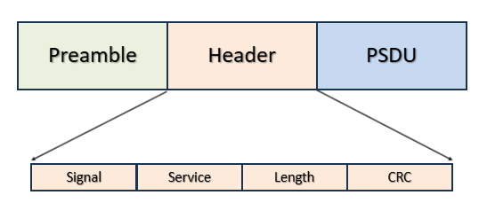
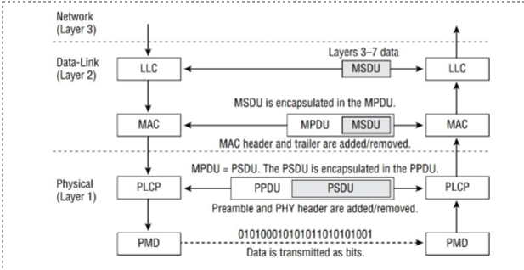
8. What is the difference between OFDM and OFDMA?
OFDM (Orthogonal Frequency Division Multiplexing) and OFDMA (Orthogonal Frequency Division Multiple Access) are both techniques used in Wi-Fi to transmit data efficiently, but they differ in how they handle multiple users.
OFDM works by dividing a single channel into many smaller subcarriers and sending data over them at the same time. However, in OFDM, only one user can use all these subcarriers at a time. This means other users have to wait for their turn, which can cause delays when many devices are connected.
OFDMA, on the other hand, is an improved version used in newer Wi-Fi standards. It also divides the channel into subcarriers, but it allows multiple users to share these subcarriers at the same time. Each user gets a portion of the channel, so data can be sent to multiple devices simultaneously.
In simple terms, OFDM serves one user at a time using all resources, while OFDMA shares those resources among many users at once. Because of this, OFDMA improves efficiency, reduces delay, and works better in crowded networks.
9. What is the difference between MIMO and MU-MIMO?
MIMO (Multiple Input Multiple Output) and MU-MIMO (Multi-User MIMO) are technologies used in Wi-Fi to improve speed and performance by using multiple antennas, but they work in slightly different ways.
MIMO allows a single device to use multiple antennas to send and receive multiple data streams at the same time. This increases the data speed and improves signal quality. However, in this case, the router communicates with one device at a time, even though it uses multiple streams.
MU-MIMO, on the other hand, is an advanced version where the router can communicate with multiple devices at the same time. It divides its antennas and data streams among different users, so several devices can receive data simultaneously without waiting.MIMO improves speed for a single user, while MU-MIMO improves performance for multiple users at the same time, making it more efficient in crowded networks.
10. What are PPDU, PLCP, and PMD in the PHY layer?
In the Wi-Fi PHY layer, terms like PPDU, PLCP, and PMD are used to describe how data is prepared and transmitted over the air.
PPDU (PLCP Protocol Data Unit) is the actual format of data that is sent over the wireless medium. It includes all the parts needed for transmission, such as the preamble, header, and the actual data. In simple terms, PPDU is the complete “packet” that travels through the air.
PLCP (Physical Layer Convergence Protocol) acts as a link between the higher layers and the physical transmission process. Its job is to take the data from upper layers, add necessary information like headers, and convert it into a PPDU format so that it can be transmitted. It ensures that the data is properly prepared and understandable at the receiver side.
PMD (Physical Medium Dependent) is the part that actually handles the transmission of signals over the air. It deals with how the data is converted into radio signals using techniques like modulation and then sent through the wireless medium.
11.What are the types of PPDU? Explain the PPDU frame format across different Wi-Fi generations.
In Wi-Fi communication, a PPDU (PLCP Protocol Data Unit) is the complete frame that is transmitted through the air from the sender to the receiver. As Wi-Fi technology has improved over time, different types of PPDUs have been developed to support higher speed, better efficiency, and more users.
There are mainly four types of PPDU based on different Wi-Fi generations. The Legacy PPDU is used in older standards like 802.11a/b/g and has a simple structure with basic performance. The HT PPDU (High Throughput) is used in 802.11n and improves speed by using technologies like MIMO. The VHT PPDU (Very High Throughput) is used in 802.11ac and supports even higher data rates and wider channels. The latest is the HE PPDU (High Efficiency) used in 802.11ax (Wi-Fi 6), which is designed to handle many devices at the same time and perform better in crowded networks.
Even though these types are different, the basic structure of a PPDU remains similar. It starts with a preamble, which helps the receiver detect and synchronize the signal. Then comes the header, which contains important details like data rate and frame length. Finally, there is the data (payload), which carries the actual information being transmitted.
As Wi-Fi generations advance, the PPDU format becomes more efficient and advanced. Newer PPDUs include features like MIMO, MU-MIMO, and OFDMA, which improve speed, reduce delay, and allow multiple users to communicate at the same time.
12. How is the data rate calculated?
In Wi-Fi, the data rate means how fast data is transmitted over the network. It depends on several factors like number of subcarriers, modulation, coding rate, and number of spatial streams.
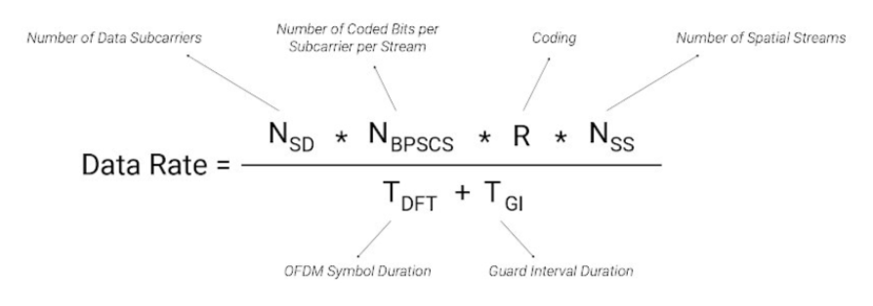

Meaning of Each Term
- Nₛd (Number of Data Subcarriers) → how many channels carry data
- N_bpscs (Bits per Subcarrier) → depends on modulation (like 256-QAM = 8 bits)
- R (Coding Rate) → efficiency (like 5/6)
- Nₛs (Spatial Streams) → number of parallel data streams
- T_DFT → symbol duration
- T_GI → guard interval (extra time to avoid errors)

